More on cin:
//a bad example
#include <iostream>
#include <string>
using namespace std;
int main() {
string name, city;
cout << "enter your full name: " ;
cin >> name;
cout << "enter the city you're living in: ";
cin >> city;
cout << "your are " << name << " who's living in " << city << endl;
system("pause");
return 0;
}

Note:
In this example, when the user tries to enter his full name(e.g Muhammad Li) the following happens:
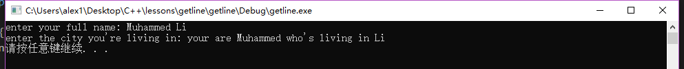

We notice 2 things:
1.The second output doesn’t active
2.The user’s last name has been assigned to the variable city

As you should know, string is just a more convinced way of creating a character array a.k.a C-style string. Turns out, cin assumes both space and change of line(enter) to be the ending of that array(‘\0’)
Moreover, when inputting numbers, the space can also be the indication of the end of that input, as you can’t have a space between any number.

Therefore, to able the user to avoid cin assuming space as the end of the string(‘\0’), we use the function cin.getline()
//a better example
#include <iostream>
using namespace std;
int main() {
const int size = 20;
char name[size], city[size];
cout << "enter your full name: " ;
cin.getline(name, size);
cout << "enter the city you're living in: ";
cin.getline(city, size);;
cout << "your are " << name << " who's living in " << city << endl;
system("pause");
return 0;
}

Console:
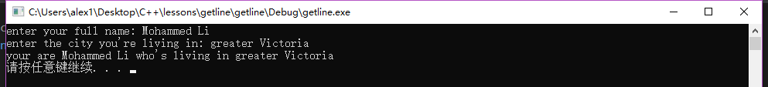

As you can see, the program now runs correctly.
Everytime the user hits ‘enter’, the program receives a ‘Newline character’. cin.getline() will tries to attempt to get that line. As a result, the program transfer the ‘Newline character’ in to ‘\0’, which ends the array
The method of getline is:
cin.getline(name_of_array,size_of_array);
Both parameters are mandatory, notice that the last element of the C-style string must be (‘\0’) or it will cause an overload. Therefore, the number of element user can input is one less than the size, in this case, it’s 19.
The rest of the array is automatically filled with empty element(not even space):
char name2[20] = { 'M','o','h','a','m','m','e','d',' ','L','i','\0' };

There is a third optional parameter, but it’s summer now and I’m lazy.

For handling more extreme situation, we can use cin.get();
//a betterer example
#include <iostream>
using namespace std;
int main() {
const int size = 20;
char name[size], city[size];
cout << "enter your full name: ";
cin.get(name, size).get();
cout << "enter the city you're living in: ";
cin.get(city, size);
cout << "your are " << name << " who's living in " << city << endl;
system("pause");
return 0;
}
Console:
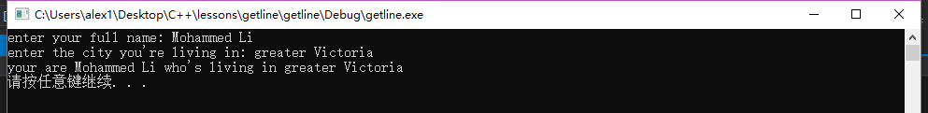

cin.get()uses the same parameter as cin.getline().
Notice that there are 2 cin.get used in the first input (they’re just combined together), that’s because in cin.get(), the ‘Newline character’ is not only become an indication of the end of the array, but also left in the console, as a result, the next cin.get() will receive this as it’s input, therefore causing 2 cin.get() being activated.
cin.get() can be used to avoid error, as if there’s an overload of input, the next cin.get() will catch some overload (depend on the previous size, in this case is 20,put your pointer on it visual studio will tell you) and allows the program to analyze
Also there's no cin.getline() in older C++;

When receiving an empty line(pressing enter right away), cin.get() will freak out and annihilate the rest of the inputs. But there’s a way to avoid this beside having a nicer user:
cin.clear();
This will reset the input.

When overloading, both cin.getline() and cin.get() will leave the overloaded bit in the console. However, cin.getline() will disable all the following input, where cin.get() can control the overload better.

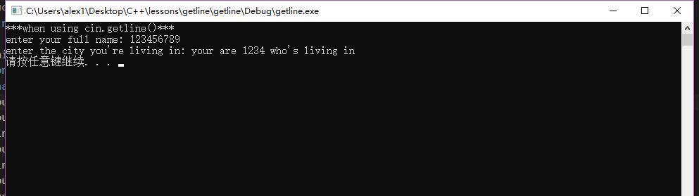

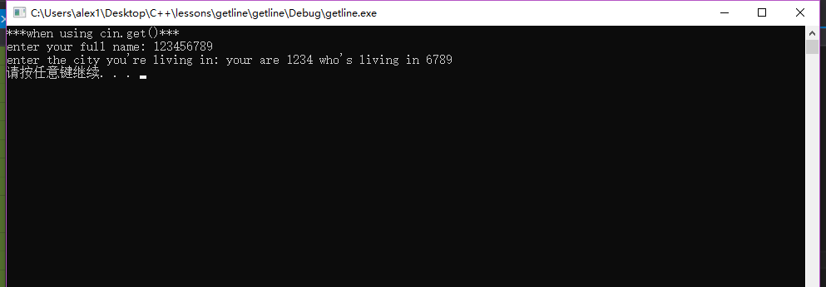

When dealing different variable types:

//a bad example
#include <iostream>
using namespace std;
int main() {
int age = 0;
const int size = 20;
char name[size];
cout << "how old are you?" << endl;
cin >> age;
cout << "what's your name?" << endl;
cin.getline(name, size);
cout << "you are " << name << " and you're " << age << " years old" << endl;
system("pause");
return 0;
}
When trying to run this program, the user doesn’t get a chance to enter the name variable:
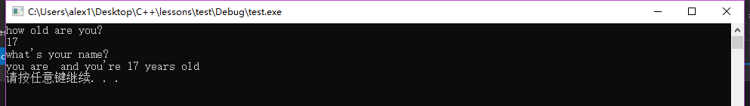

By inputting a integer, we return not only an number, but also a ‘New line character’ which is left in the console and becomes the input of the cin.getline(). Therefore, to fix this, we just need to get rid of that character.

//a better example
#include <iostream>
using namespace std;
int main() {
int age = 0;
const int size = 20;
char name[size];
cout << "how old are you?" << endl;
(cin >> age).get();
cout << "what's your name?" << endl;
cin.getline(name, size);
cout << "you are " << name << " and you're " << age << " years old" << endl;
system("pause");
return 0;
}

Congrats, you can allow users input now.

